**Stage 3 - "He should have armed himself..."**

**COURSE DESIGNER:** Ryan Christenson

|  |
| --- |
| **SCORING:** Comstock 28 rounds.  **TARGETS:** 10 cardboard targets, 8 steel targets.  **SCORED HITS:** 2 Best hits per carboard will be scored. Steel must fall to score. |

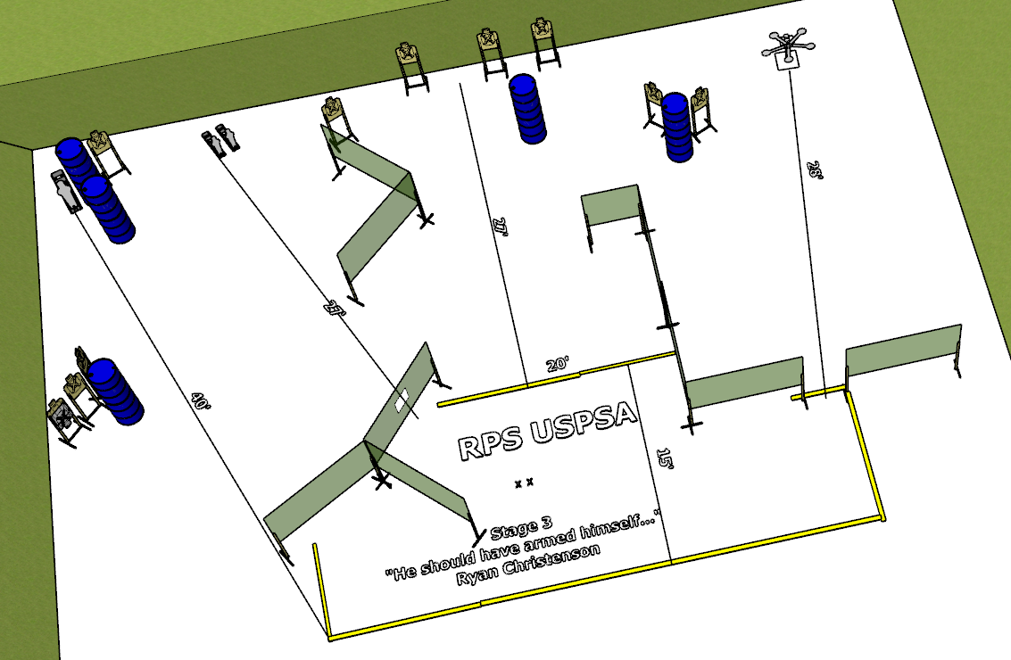

**Written Stage Briefing:**

**Stage 3 - "He should have armed himself..."-** is a 28-round, 140 point, Comstock Long Course. There are 10 cardboard targets and 8 steel targets. The best 2 hits per cardboard target will be scored. The steel must fall to score.

**Start position** Both feet on the Shooting Sports Innovations Xs.

**Handgun**: Unloaded and holstered.

**PCC**: Unloaded, held in both hands.

On the audible start signal, engage targets from within the shooting area.

**USPSA / NROI Range Commands:**

* Make Ready
* Are you ready?
* Standby
* If finished, unload and show clear.
* If clear, hammer down and holster
* Range is clear

**Setup Notes:**

8 Single Wall Stands

5 Double Wall Stands

8 Full Walls

1 Half Walls

10 Target stands / 20 target sticks

1 Popper

2 Mini Poppers

3 Popper bases

1 Texas Star

10+ barrels

